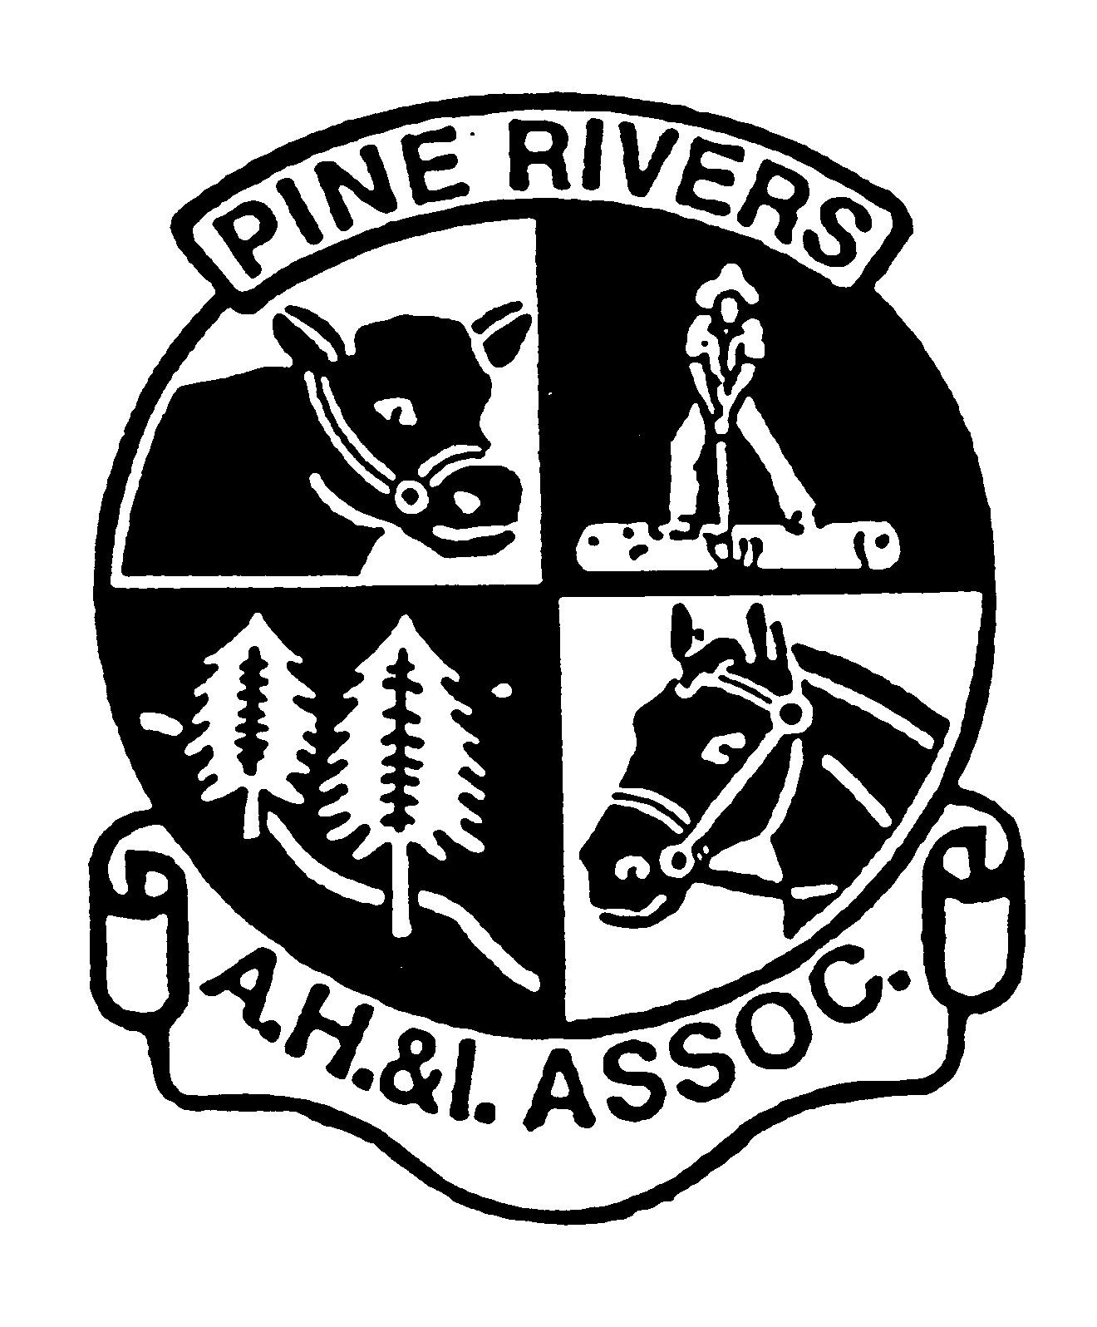
PINE RIVERS SHOW

CELEBRATING 120 YEARS

1st, 2nd & 3rd
AUGUST

2025
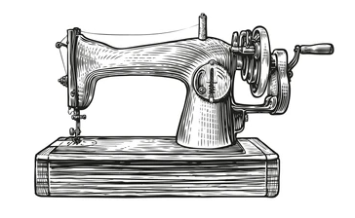

NEEDLEWORK SCHEDULE

FOR FURTHER INFORMATION PLEASE CONTACT THE CHIEF STEWARD
Web: www.pineriversshow.org.au
email: office@pineriversshow.org.au

PINE RIVERS A.H. & I. ASSOCIATION
NEEDLEWORK - SECTION 8

STEWARDS: SAMANTHA HORNE 0412 093 228
JENNY BAILEY 0408 125 357

SHOW OFFICE: 3205 2597

ENTRIES: All exhibits are to be delivered to the Wyruna room at the showgrounds on:
Sunday 27th July 2025 from 10.00am-1.00pm
Monday 28th July 2025 from 4.30PM-6.30PM
NO LATE ENTRIES WILL BE ACCEPTED
All entries for judging must by entered to needlework build entered as per time stated.

PICK UP: Exhibits SHOULD be collected from the needlework pavilion.
ON MONDAY 4th AUGUST 2025 FROM 3PM TO 6.00PM
Alternative arrangements to collect articles may be made by phoning the Show Secretary
on 3205 2597.

ENTRY FEES All Classes $2.00 per entry

PRIZE MONEY: FIRST PRIZE MINIMUM VALUE $25.00

SECOND PRIZE MINIMUM VALUE $15.00
THIRD PRIZE RIBBON ONLY

Any PRIZE STATED MAY BE SUBSTITUTED WITH A CASH OR VOUCHERS TO THAT VALUE.

IMPORTANT CONDITIONS OF ENTRY (ASSOCIATIONS REGULATONS)

- TO QUALIFY FOR NEEDLEWORK SECTION - ENTRY MUST BE EXECUTED (all or part thereof)
WITH CROCHET HOOK OR NEEDLE (FELTING, KNITTING, HAND, OR MACHINE).

- ENTRY FORM MUST ACCOMPANY ALL ENTRIES when they are DELIVERED.
IF NAME OF EXHIBITOR IS ATTACHED, THIS MUST BE HIDDEN FROM JUDGES VISION.

- If an article of needlework has previously won a prize at the pine rivers show,
It is not eligible for judging in this competition.

- The Stewards reserve the right to declare a non-competition in any class in which there are less than three entries or where insufficient articles are entered in a class, some classes may be combined.
The Stewards have the right to determine matters relating to any Class in Needlework. Stewards’ decisions are final.

- We regret that the above Association cannot accept any liability for loss or damage of entries while in the custody of the Association, however all due care will be exercised. (Please ensure all hanging wires are of ample strength.)

- Please retain receipt for entry fees & produce it as proof of ownership of items for pick up.

- All exhibits must be the work of the competitor & to be made within the last eighteen months.

- ALL EXHIBITS MUST BE COLLECTED ON MONDAY 4th AUGUST BETWEEN 3.00PM AND 6.00PM.

- Entries can be sold during show. A commission of 10% will be retained.

- all items for sale must have a price tag attached, showing the name and cost (first three letters of surname e.g. smith = smi, smi2 etc) and price.

- if you wish for your quilt to be hang, please have a sleeve attached to back of quilt. If no sleeve attached exhibitor must pin on fabric tab provided.

- All entries for judging must by entered to needlework build entered as per time stated.

CROCHET
CLASS NO
01 Any Rug
02 Any item in crochet not mentioned above.
Includes all toys bear and dolls.
KNITTING HANDMADE:
03 Bed rug, Knee Rug or Afghan Rug
04 Any other hand-knitted item not mentioned.
Includes all toys bear and dolls.

EMBROIDERY
05 Picture in counted cross-stitch & framed.
06 Any other hand embroidered article

PATCHWORK & QUILTING
07 Any patchwork QUILT.

08. Any other patchwork items.

MISCELLANEOUS
09. Any type of Bag
10 Any computerised machine embroidery.
11. Any hand-crafted Dolls Toys or Bears.
Excludes knitted and crochet.
12 Any dressed doll or bear, clothing made by entrant.
13 Any item not mentioned above.
(EXCLUDES ANY QUILT)

SCHOOL STUDENTS

(Please state age and year level of student)

14. Any Primary School Entrant

15. Any High School Entrant.

OVER 70'S
16 Any article of Knitting or Crochet.
17. Any machine-made article.
(EXCLUDES QUILTS)
18. Any hand worked Item,
19. Any Nursing/Care Home group item.

INDIVIDUAL CREATIVE
20. Any item Christmas Themed
21. Any Christmas Wall Hanging

ANY OF THE ABOVE CLASSES CAN BE SPLIT AT JUDGES DISCRETION.

SPECIAL AWARDS

GRAND CHAMPION EXHIBIT OF NEEDLEWORK
RIBBON donated by Q.C.W.A. Pine Rivers

JUNIOR CHAMPION EXHIBIT OF NEEDLEWORK
RIBBON donated by OLDE SHOWBAGS

JUNIOR ENCOURAGEMENT AWARD
RIBBON donated by PINE RIVER A.H&I

EILEEN HORNE VIEWER’S CHOICE
RIBBON donated by OLDE SHOWBAGS

STEWARD / HANGERS AWARD (quilt only)
RIBBON donated by Pine River A.H&I
PRIZE donated by CHERABELLA BUTTONS

GAY FETHERSTONHAUGH AWARD FOR CROCHET/KNITTING
RIBBON & PRIZE donated by Q.C.W.A. Pine Rivers
ENTRY FORM

N E E D L E W O R K
PINE RIVERS A.H. & I. ASSOCIATION

NAME: ...................................................... TELEPHONE NO.: .................………........

ADDRESS: ........................................................…………………………………………...

Email.................................................................................…… POSTCODE……………...
*STUDENT ENTRIES
SCHOOL AGE: ………………GRADE: ……………SCHOOL: ……………………………………….……………………
I have read and agree to the conditions and regulations of the Association
I acknowledge that I will collect my exhibit on Monday 4^{h} August between 3.00pm & 6PM.

SIGNED: _________________________________ DATE: ______________________

Please ensure fully completed Entry form together with entry monies are presented to Chief Steward at time of entry. Judging entered by steward.

CLASS | JUDGING NO. | DESCRIPTION | NUMBER OF ENTRIES

