PINE RIVERS 119th SHOW
2nd, 3rd & 4th August 2024
POULTRY SECTION
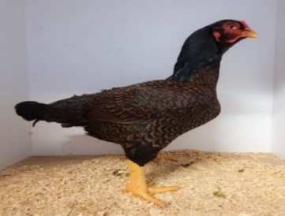
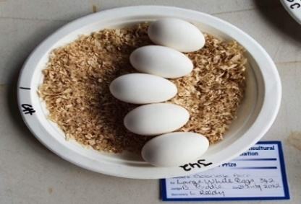
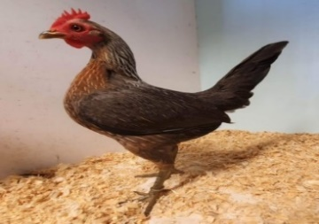

Judging Sunday 4th August for Poultry
Saturday 3rd August
Judging of Novelty Classes
Birds must be penned by 10.00am
JUDGING COMMENCES AT 10.45am
Poultry Display with Questions & Demonstrations during the day
Chief Steward: David Simons 294 Old Toorbul Rd, Caboolture Q 4510
Phone contact: (07) 54990553
Email: dsimons1@bigpond.com
Assist Show Steward: Linda Reedy
Stewards: Moreton Bay Regional Poultry Inc Club Members
Saturday Novelty Class REGULATIONS:
- Open to all ages of fowls and exhibitors.
- These classes are open to any breed of fowls, not necessarily pure breeds.
- They can be your Special Backyard Chooks, but MUST be free of any lice, stick fast fleas, scaly leg mite or any other problems or disease.
- NOTE: The Biosecurity Form needs to be completed for all entries.
- They MUST be presented in a clean and tidy condition.
- There are no entry fees for this Section and NO prize money will be allocated for any winners of this Section. All Juvenile Entrants in the Novelty Classes will receive a ribbon and certificate for their entries
 | Male | Female
Most Handsome Rooster | 400
Prettiest Hen |  | 401
Friendliest Chook | 402 | 403
Best Dressed Chook in Chook Clothes | 404 | 405
Fattest Chook | 406 | 407
Ugliest Chook | 408 | 409
Chook that most looks like its owner | 410 | 411
Best dressed waterfowl | 412 | 413
Best Decorated Egg/s –under 5
Best Decorated Egg/s Open
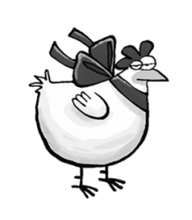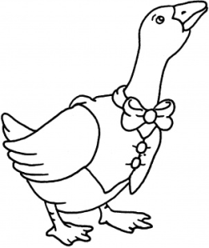
Sunday 4th August 2024
Birds must be penned by 8.30am
JUDGING COMMENCES AT 9.00am

All entries MUST be received to the Chief steward before or by Thursday 1st August

Chief steward: Linda Reedy lindareedy51@gmail.com
0407 125 562

Stewards: Moreton Bay Regional Poultry Inc Club Members
JUDGES:
Grame Hopf
Doug Freeman
Grace Worthy

REGULATIONS:
- All entries to be submitted on the official Pine Rivers A H & I Association Entry Form – are to be payable to Pine Rivers A H & I Association please.
- Biosecurity: form to be completed and submitted with show entries please.
- During the judging, all exhibits will be in the custody of the stewards and shall not be handled by the owner or any persons other than the judge or steward unless previous consent from a steward has been obtained.
- During the judging, exhibitors are asked to keep the judging area free so as not to hinder the judges or stewards.
- The judges’ decisions shall be considered final and no further discussion concerning the matter will be entered.
- Any parasite infected or diseased fowls will be disqualified and removed from the pavilion.
- Water containers will be provided by the Moreton Bay Regional Poultry Club for the well-being of the exhibits and remain the property of the Poultry Club.
- Every care will be taken of the exhibits, but the committee will not be liable for damage, loss, or death.
- No bird is to be removed early from the pavilion unless a clearance is obtained from the Chief steward.
- Presentation of awards will be approximately between 2.00pm and 3.00pm. Birds are to remain penned until 4pm and only released under the guidance of the stewards.

PRIZE MONEY ENTRY FEE $1.00

- Champion Award $10
- First Prize $5
- Second Prize $3
- Third Prize $2
- First, Second and Third Cards will be awarded.
- Where 1 fowl is entered in a category, the judge will award the position at the judge’s discretion.

Large Softfeather Class | Cock | Hen | Cockerel | Pullet
Ancona | 1 | 2 | 3 | 4
Australian Langshan | 5 | 6 | 7 | 8
Australorp | 9 | 10 | 11 | 12
Croad Langshan | 13 | 14 | 15 | 16
Hamburgh A.C. | 17 | 18 | 19 | 20
Houdan | 21 | 22 | 23 | 24
Leghorn A.C. | 25 | 26 | 27 | 28
Orpington A.C. | 29 | 30 | 31 | 32
Plymouth Rock | 33 | 34 | 35 | 36
Polish A.C. | 37 | 38 | 39 | 40
Rhode Island Red S/C | 41 | 42 | 43 | 44
Rhode Island Red R/C | 45 | 46 | 47 | 48
Rhode Island White | 49 | 50 | 51 | 52
Silkie White | 53 | 54 | 55 | 56
Silkie A.O.C | 57 | 58 | 59 | 60
Sussex Light | 61 | 62 | 63 | 64
Sussex AOC. | 65 | 66 | 67 | 68
Wyandotte Gold Laced | 69 | 70 | 71 | 72
Wyandotte A.O.C | 73 | 74 | 75 | 76
AOV S/F Large | 77 | 78 | 79 | 80
Large Hardfeather Class | Cock | Hen | Cockerel | Pullet
Australian Game A.C. | 81 | 82 | 83 | 84
Indian Game A.C | 85 | 86 | 87 | 88
Malay Game A.C. | 89 | 90 | 91 | 92
Modern Game A.C. | 93 | 94 | 95 | 96
OEG Black Red DL | 97 | 98 | 99 | 100
OEG Blue Red/Duckwing | 101 | 102 | 103 | 104
OEG Pile | 105 | 106 | 107 | 108
OEG AOC | 109 | 110 | 111 | 112
OEG Hen Feather | 113 | 114 | 115 | 116
Pit Game Heavy PF | 117 | 118 | 119 | 120
Pit Game Light PF | 121 | 122 | 123 | 124
Pit Game Muff | 125 | 126 | 127 | 128
AOV H/F Large | 129 | 130 | 131 | 132

Bantam Softfeather Class | Cock | Hen | Cockerel | Pullet
Ancona S/C | 133 | 134 | 135 | 136
Ancona R/C | 137 | 138 | 139 | 140
Araucana A.C. | 141 | 142 | 143 | 144
Australian Langshan A.C. | 145 | 146 | 147 | 148
Australorp A.C | 149 | 150 | 151 | 152
Belgian A.V | 153 | 154 | 155 | 156
Frizzle A.C. | 157 | 158 | 159 | 160
Japanese A.C. | 161 | 162 | 163 | 164
Leghorn A.C. | 165 | 166 | 167 | 168
Pekin Black | 169 | 170 | 171 | 172
Pekin Blue | 173 | 174 | 175 | 176
Pekin Buff | 177 | 178 | 179 | 180
Pekin White | 181 | 182 | 183 | 184
Pekin AOC | 185 | 186 | 187 | 188
Plymouth Rock | 189 | 190 | 191 | 192
Polish A.C. | 193 | 194 | 195 | 196
Rhode Island Red S/C | 197 | 198 | 199 | 200
Rhode Island Red R/C | 201 | 202 | 203 | 204
Rhode Island White | 205 | 206 | 207 | 208
Rosecomb A.C. | 209 | 210 | 211 | 212
Sebright A.C. | 213 | 214 | 215 | 216
Sussex A.C. | 217 | 218 | 219 | 220
Wyandotte White | 221 | 222 | 223 | 224
Wyandotte AOC | 225 | 226 | 227 | 228
AOV S/F Bantam | 229 | 230 | 231 | 232
Bantam Hardfeather Class | Cock | Hen | Cockerel | Pullet
Australian Game A.C. | 233 | 234 | 235 | 236
Indian Game Blue | 237 | 238 | 239 | 240
Indian Game Dark | 241 | 242 | 243 | 244
Indian Game Jubilee | 245 | 246 | 247 | 248
Modern Game Birchen | 249 | 250 | 251 | 252
Modern Game Black Red | 253 | 254 | 255 | 256
Modern Game Brown Red | 257 | 258 | 259 | 260
Modern Game Duckwing A.C. | 261 | 262 | 263 | 264
Modern Game Wheaten A.C. |  | 265 |  | 266
Modern Game AOC | 267 | 268 | 269 | 270
OEG Black Red DL | 271 |  | 272
OEG Partridge DL |  | 273 |  | 274
Bantam Hardfeather Class | Cock | Hen | Cockerel | Pullet
OEG Black Red LL | 275 |  | 276
OEG Partridge LL |  | 277 |  | 278
OEG Wheaten A.C. |  | 279 |  | 280
OEG Duckwing A.C. DL | 281 | 282 | 283 | 284
OEG Duckwing A.C. LL | 285 | 286 | 287 | 288
OEG Blue Red | 289 | 290 | 291 | 292
OEG A.O.C | 293 | 294 | 295 | 296
Pit Game P.F. | 297 | 298 | 299 | 300
Pit Game Muff | 301 | 302 | 303 | 304
AOV H/F Bantam | 305 | 306 | 307 | 308
 | Male | Female
Guinea Fowl A.C. | 309 | 310
Waterfowl | Male | Female
Muscovy White | 311 | 312
Muscovy AOC | 313 | 314
Indian Runner A.C. | 315 | 316
Campbell A.C. | 317 | 318
Pekin | 319 | 320
AOV Large | 321 | 322
Australian Call A.C. | 323 | 324
Mallard A.C. | 325 | 326
AOV Bantam/Miniature | 327 | 328
Any Variety Geese | 329 | 330
Breeding Pairs –
(1 Male and 1 Female)
Large Softfeather | 331
Large Hardfeather | 332
Bantam Softfeather | 333
Bantam Hardfeather | 334
Waterfowl | 335

Pair of Females
Large Softfeather | 336
Large Hardfeather | 337
Bantam Softfeather | 338
Bantam Hardfeather | 339
Waterfowl | 340
EGG SECTION
(6 EGGS PER ENTRY)
Large Brown | 341
Large White | 342 | 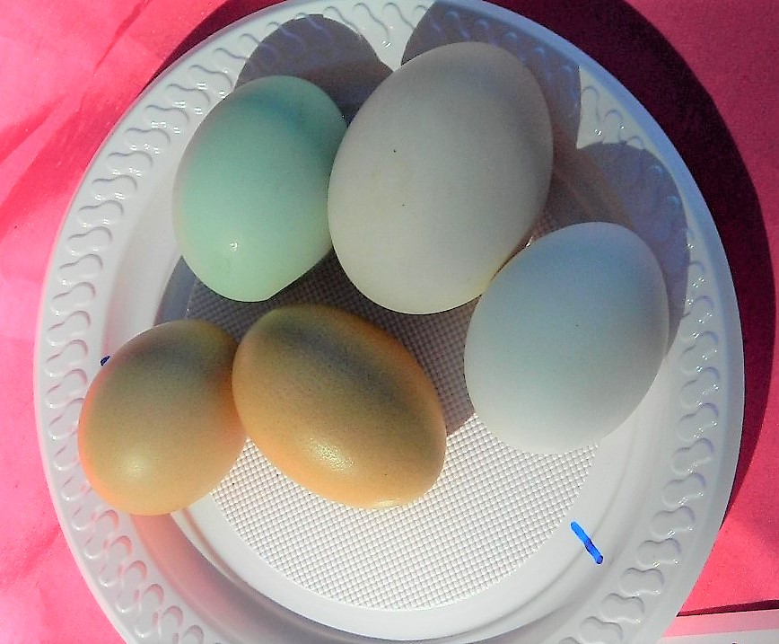
Large AOC | 343
Bantam Brown | 344
Bantam White | 345
Bantam AOC | 346
Waterfowl | 347 | A Plate of Eggs Champion
AOV Eggs | 348
Mixed Plate of 6 Eggs | 349

JUNIOR SECTION
- Limit 2 entries per child
- No entry fee
- Open to children under 14 years of age
- The relevant junior exhibitor must pen the birds
- Birds are judged on presentation and cleanliness only

Class A | Large Softfeather | Class B | Large Hardfeather
Class C | Bantam Softfeather | Class D | Bantam Hardfeather
Please note all junior entries are FREE
AWARDS & DONATIONS

GRAND CHAMPION FOWL OF SHOW
Sash and cash donated by Moreton Bay Regional Poultry Club Inc - $100.00

RESERVE CHAMPION FOWL OF SHOW
Sash and cash donated by Moreton Bay Regional Poultry Club Inc - $50.00

MAJOR AWARDS
Champion Large Softfeather Fowl Sash $20 donated by Gabrielle Parr
Champion Large Hardfeather Fowl Sash $20 donated by Elsie Carlton
Champion Bantam Softfeather Fowl Sash $20 donated by MBPC
Champion Bantam Hardfeather Fowl Sash $20 donated by MBPC
Champion Rare Breed Sash $20 donated by Peter Gambell
Champion Crested Breed Sash $20 donated by D& D Simons
Champion Large Waterfowl Sash $20 donated by Linda Reedy
Champion Bantam Waterfowl Sash $20 donated by B&J Hutchinson
Champion Goose/Gander Sash $20 donated by Albert Freeman
Champion Breeding Pair O/A Sash $20 donated by Grace Worthy
Champion Pair of Females O/A Sash $20 donated by Gary Tavener
Champion Eggs Sash $20 donated by Linda & Michael

SECTION CHAMPIONS - Sashes
Large Softfeather Best Male Best Female
Large Hardfeather Best Male Best Female
Softfeather Bantam Best Male Best Female
Hardfeather Bantam Best Male Best Female
Waterfowl Best Male Best Female

ENCOURAGEMENT AWARD

JUNIOR SECTION TROPHIES donated by
Doug Freeman
LUCKY EXHIBITOR PRIZE
Win a bag of Feed
Donated by Albert Freeman
Every 5 entries entitle you to a ticket in a bag of feed.
Drawn at Presentation

ENTRY FEE - $1.00 JUNIOR SECTION FREE
To the Secretary: Subject to the Rules and By-laws of the Association and the Queensland Chamber of Agricultural Societies, which are deemed to be therein at length, I wish to make the following entries for the forthcoming Show, the same being my own bona fide property.
ALL ENTRY FEES TO BE PAID BEFORE EVENTS.
NO. OF CLASS | NO. OF ENTRIES | BREED/ VARIETY | $. | C | PEN NO:
Name of Exhibitor (Mr/Mrs/Ms/ Miss)
(NAME IN BLOCK LETTERS PLEASE)
Address Postcode ________
Telephone Date _______/________/_____
Post/Email all entries to the Chief steward by Wednesday 31st July
CHIEF STEWARD Linda Reedy lindareedy51@gmail.com
0407 125 562

Thank you to our sponsors, judges, exhibitors, and workers
Without your assistance there would not be a show

ALL ENTRY FEES TO BE PAID BEFORE EVENTS.
NO. OF CLASS | NO. OF ENTRIES | BREED/ VARIETY | $ | C | PEN NO:

BIOSECURITY FORM
EXHIBITOR DETAILS
NAME TO APPEAR ON PRIZE CARDS (EG PERSON, STUD OR FAMILY NAME):

FULL NAME OF PERSON IN CHARGE OF POULTRY
HOME ADDRESS OF PERSON IN CHARGE
POSTAL ADDRESS OF PERSON IN CHARGE
EMAIL:
PHONE: | MOBILE:

INSERT/INCORPORATEPREVIOUS POULTRY ENTRY FORM

PROPERTY OF ORIGIN OF ANIMALS
FULL ADDRESS:
(if different to above)
PIC NUMBER:  (Property Identification Code) | (ONLY REQUIRED IF PROPERTY HAS OVER 100 BIRDS)  _ _ _ _ _ _ _ _
Event PIC NUMBER  (Property Identification Code) | QIPR 0390
Destination Properties:
(Full address)
Only list if not returning all original property nominated above.
(Include Property Identification Code if applicable)

Declaration by owner or person in charge of poultry attending:
I, ____________________________________________________ declare that the animals named above has / have been in good health, eating normally and not shown signs of illness during the last 3 days leading up to this event. I give my authorisation for the Event Organising Committee/Manager to call for veterinary inspection of the animals named above and, in my care, should they be showing signs of illness at any time during the course of the event. I agree to pay any veterinary fees incurred for the abovementioned animals as a result of this veterinary examination.
I AGREE TO ENSURE THAT PRIOR TO ARRIVAL:
1. All animals will be shampooed and or cleaned, rinsed and allowed to dry, and their hooves/legs/feet will have been picked clean of all solid material and washed with shampoo.
2. All vehicles and equipment accompanying the animals will be cleaned to remove all solid material that could contain disease agents, and then disinfected.
I FURTHER DECLARE THAT:
3. The information contained in this Biosecurity Declaration and Movement Record is true and correct to the best of my knowledge.
4. I agree to abide by all conditions that may be imposed at any time by the Event Organising Committee/Manager. I also agree to abide by and accept the regulations as printed in the schedule and make these entries subject to such regulations and rules of the committee.
5. I acknowledge that in failure to comply, I may be directed to leave and my nominations will be forfeited.
6. I acknowledge that decontamination and disinfection procedures may be required of me if instructed by the Event Organising Committee/Manager.
7. All animals described above are free of cattle ticks before entering the event.
8. I acknowledge that the animals above are from a JOHNE’S DISEASE-FREE herd/flock. This is a herd with no clinical cases detected in the last 5 years.
9. I acknowledge the above-mentioned animals to the best of my knowledge are free from any other notifiable diseases. If unsure what notifiable diseases effect your breed of animal/s, please look at the list provided by DAF https://www.daf.qld.gov.au/animal-industries/animal-health-and-diseases/notifiable
10. I acknowledge that there is a possibility that animals might become infected with disease agents as a result of any movements and if necessary, animals and premises will be place on a restricted list in accordance with any Legislation covering such occurrences including policies and procedures in effect at that time. I agree and acknowledge that the Manager/Event Organising Committee, it’s State or National Affiliated bodies and their members are not in any way liable for any cost, expense, loss, damage, claim, action, proceeding or other liability incurred by or made against me as a result of any movement of animals to the Event/Farm.

Signature Date
________/________/______

NOTE: It is recommended to keep a copy of this form by the owner or person in charge of animal/s and event committee for a minimum of 5 years.

